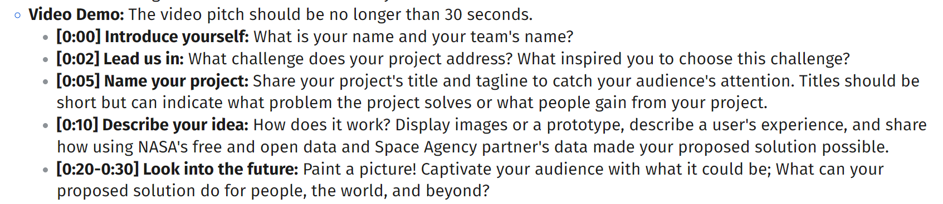

—------

**OPTION 1**

The boundless impact

**Welcome to the TerraGuard!**

**Our project about "Imagine our connected Earth"**  (((pokazać scrolling challenge na stronie NASA)

**NASA data can provide a complete view to the situation in the world. If we collect NASA data in one place we can see that some actions lead to another, that everything is connected closely. You can't avoid the consequences of your actions, but how do you know what depends on what?** ((( gra już zaczyna się, pokazać jak przez zabójstwo wszystkich pszczół zniknęli jakieś kwiatki, czy coś podobne, żeby pokazać co znaczy "very closely")))

====== about 13 seconds

**Imagine the game that educates others about how different systems communicate with each other. After bad choices you see the effects** ((show bad effects)).

**You can destroy or help your real world created based on NASA data in real time. It also lives its own life and something unexpected can happen** (((show random bad/good events))).

**Winning can lead to good prizes.** (((pokazać nagrody i staże, satysfakcję studenta za otrzymany staż, po prostu pobierzemy gdzieś w internecie)).

**Try to save your planet, It is not too late!**

==== about 15 seconds

– dodać jak cała grupa macha rękami i camera się oddala, poprosimy kogoś to nagrać (w regułach napisane "przedstawić grupę", tego chyba starczy)

—

**OPTION 2**

Welcome to the FutureWorld!

Our project about "Imagine our connected Earth" (((pokazać scrolling challenge na stronie NASA)

The data is a fundamental aspect. The data about earth is a power which is given to a people. Our mission is to allow their use in a correct way.

PROTOTYP: <https://www.figma.com/design/Ay2RAddJzvd4eRDSvgkF50/Untitled?node-id=19-25&t=UA9jWjjzSkUOIGGr-1>

PC VIEW: https://www.figma.com/proto/Ay2RAddJzvd4eRDSvgkF50/Untitled?node-id=95-331&node-type=frame&t=EIfIlqb5EnnAUox7-1&scaling=min-zoom&content-scaling=fixed&page-id=0%3A1&starting-point-node-id=95%3A331

—--

The boundless impact

Welcome to the TerraGuard!

Our project about "Imagine our connected Earth"

NASA data can provide a complete view to the situation in the world. If we collect NASA data in one place we can see that some actions lead to another, that everything is connected closely. You can't avoid the consequences of your actions, but how do you know what depends on what?

Imagine the game that educates others about how different systems communicate with each other. After bad choices you see the effects

You can destroy or help your real world created based on NASA data in real time. It also lives its own life and something unexpected can happen

Winning can lead to good prizes

Try to save your planet, It is not too late!